Wcf broker sample code: hello world r2 .net version

unpack the sample code
- Log onto the head node
- Goto C:\ and unpack the WcfBrokerR2Samples.zip such that the C:\WcfBrokerR2Samples is created and contains the “DotNet” and “Java” folders
- Goto the “DotNet” folder

Build and deploy the dotnet service

build the service
Open “HellowWorldR2.sln” and compile the “Release” version of the code, the result is that EchoService.dll gets created in C:\WcfBrokerR2Samples\DotNet\HelloWorldR2\EchoService\bin

deploy the service
- Copy EchoService.dll (C:\WcfBrokerR2Samples\DotNet\HelloWorldR2\EchoService\bin) to every compute node under the folder c:\ServicesR2.
- Update C:\ WcfBrokerR2Samples\DotNet\HelloWorldR2\EchoService\EchoService.config’s “assembly” entry to make it point to the full DLL path (e.g. C:\ServicesR2\EchoService.dll ).
- Copy C:\ WcfBrokerR2Samples\DotNet \HelloWorldR2\EchoService\EchoService.config to the headnode’s %CCP_HOME%\ServiceRegistration.

deploy the service TO HPc cluster in Azure
- Copy EchoService.dll (C:\WcfBrokerR2Samples\DotNet\HelloWorldR2\EchoService\bin) and EchoService.config (C:\ WcfBrokerR2Samples\DotNet\HelloWorldR2\EchoService\EchoService.config) to the folder c:\ServicesR2.
- Use hpcpack to create the service package: c:\ServiceR2\hpcpack create EchoService.zip EchoService.config,EchoService.dll.
- Upload the hpcpack to upload the service package: c:\ServiceR2\ hpcpack upload EchoService.zip /account:[service] /key:[storagekey]
- On the Azure Cluster run clusrun to deploy the service: clusrun hpcsync [service] [storagekey] ^%ccp_package_root^%

build client

add service reference
  - Add a Console Application Project named “HelloWorldR2”
  - Under the “Solution Explorer” pane, select HelloWorldR2 and References. Right click and select “Add Service References …” to open the “Add Service Reference” dialog
  - Click “Discover” to find the service defined in the solution
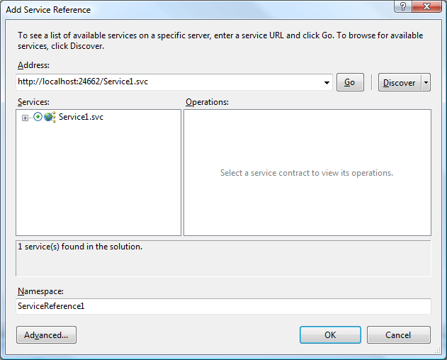
  - Click “Advanced…” to open the “Service Reference Settings”. Select “Always generate message contracts” and click “OK”
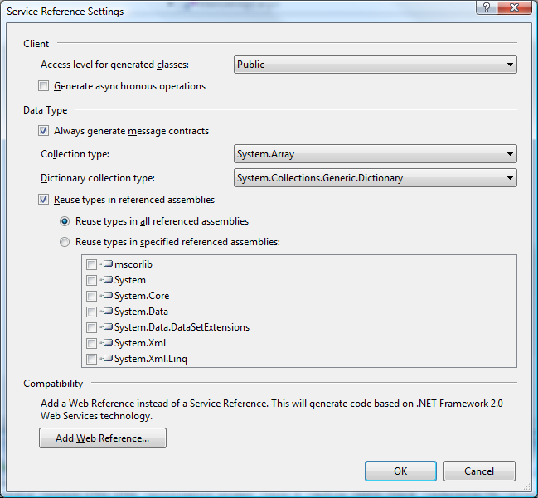

Write the client
- Add the following code to the Program.cs file:
// THIS CODE AND INFORMATION IS PROVIDED "AS IS" WITHOUT WARRANTY OF
// ANY KIND, EITHER EXPRESSED OR IMPLIED, INCLUDING BUT NOT LIMITED TO
// THE IMPLIED WARRANTIES OF MERCHANTABILITY AND/OR FITNESS FOR A
// PARTICULAR PURPOSE.
//
// Copyright (c) Microsoft Corporation. All rights reserved.

using System;
using System.Collections.Generic;
using System.Linq;
using System.Text;
using Microsoft.Hpc.Scheduler.Session;
using HelloWorldR2.EchoService;
using System.ServiceModel;

namespace HelloWorldR2
{
class Program
{
static void Main(string[] args)
{
//change the headnode name here
const string headnode = "[headnode]";
const string serviceName = "EchoService";
const int numRequests = 12;

SessionStartInfo info = new SessionStartInfo(headnode ,serviceName );

Console.Write("Creating a session for EchoService...");

using (DurableSession session = DurableSession.CreateSession(info))
{
Console.WriteLine("done session id = {0}", session.Id);
NetTcpBinding binding = new NetTcpBinding(SecurityMode.Transport);

using (BrokerClient<IService1> client = new BrokerClient<IService1>(session, binding))
{
Console.Write("Sending {0} requests...", numRequests);
for (int i = 0; i < numRequests; i++)
{
EchoRequest request = new EchoRequest("hello world!");
client.SendRequest<EchoRequest>(request, i);
}

client.EndRequests();
Console.WriteLine("done");

Console.WriteLine("Retrieving responses...");
foreach (var response in client.GetResponses<EchoResponse>())
{
try
{
string reply = response.Result.EchoResult;
Console.WriteLine("\tReceived response for request {0}: {1}", response.GetUserData<int>(), reply);
}
catch (Exception ex)
{
Console.WriteLine("Error occured while processing {0}-th request: {1}", response.GetUserData<int>(), ex.Message);
}
}

Console.WriteLine("Done retrieving {0} responses", numRequests);
}

session.Close();
}

Console.WriteLine("Press any key to exit.");
Console.Read();
}
}
}

- Compile the code
- Run the code by pressing Ctrl-F5
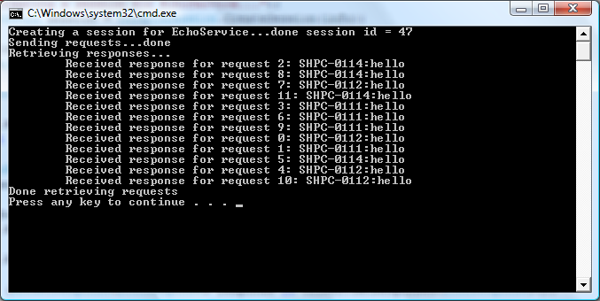

service CODE Tracing
In the service code, WCF tracing is supported.
- To add trace in service code Use the ServiceContext.Logger as the TraceSource in the service code, e.g.
ServiceContext.Logger.TraceEvent(TraceEventType.Start, 100, "In Echo Service {0}", input);
ServiceContext.Logger.TraceData(TraceEventType.Information, 200, input);
ServiceContext.Logger.TraceInformation(input);

- To configure the service trace level. Open Admin Console, under Configuration wunderbar, click on the services. In the service list view, choose the service “EchoService”, in the right click menu, choose “Set Event Logging Level …”. In the pop up dialog, choose the trace level you want and click OK.
- To collect the trace logs. After running the HelloWorldR2 client, open Admin Console, under Job Management wunderbar, click on All Jobs. Choose “Collect Trace …” on the right click menu over the finished session job. In the pop up dialog, fill in the path of a network share which computer nodes can write, e.g. \\[HN]\CcpSpoolDir, click OK.
- To view the trace logs. The service code log files are wcf trace log files with naming <JobId>_<TaskId>_trace.svclog. They can be opened and viewed in the SvcTraceViewer.exe. The logs are grouped by the ActivityId/MessageId.

Note on the source code
There are 9 client samples in HelloWorldR2.sln:
- HelloWorldR2 demos how to use the new Session API provided by HPC Server R2 to send requests and get responses on a HPC Server R2 cluster.
- HelloWorldR2Linq demos how to use Linq for querying responses.
- HelloWorldR2ErrorHandle demos how to write a reliable client by dealing with exceptions and retrying.
- HelloWorldR2Callback is the same as HelloWorldR2 besides it also demos how to get result by registering a callback.
- HelloWorldR2MultiBatch is the same as HelloWorldR2 besides it also demos how to share a session between multiple clients (or client applications) by specifying a unique client id when creating and attaching clients.
- FireNRecollect demos how to send requests in one process and coming back to retrieve the result using AttachSession in another process.
- HelleWorldR2CancelReuqests demos how to cancel the processing requests in a broker client by close the client with purging.
- HelloWorldR2OnExit/EchoService demos how to register the OnExiting handler for the service host to do cleanup work when it is gracefully closed.
- HelloWorldR2ServiceVersioning shows how to use services of different versions which are specified by the service config files on the cluster side.
- HellowWorldR2SessionPool demos how to use session pool to shorten the time for creating sessions
- InprocessBroker demos how to create an interactive session with inprocess broker instead of a dedicated broker node.
- HellowWorldR2ReliableBrokerClient demos how to use reliable broker client for durable sessions to handle the network failures when sending/flushing/ending requests or getting responses.

